# The political economy of national climate policy: architectures of constraint and a typology of countries

### William F. Lamb & Jan C. Minx

The continued failure of countries to embark on deep decarbonisation pathways requires explanation. In this paper we take a comparative political economy lens to identify national constraints that actively hinder climate policy progress. We discuss different metrics of climate policy progress, including emissions trends, climate legislation adoption, policy adoption, policy stringency, and policy outcomes. We then review literatures that attempt to explain varying national outcomes along these dimensions. Interest-based constraints include (but are not limited to) exposure to fossil fuel extraction activities and supply-side coal dependency; institutional constraints include a lack of democratic norms and exposure to corruption; while idea-based constraints constitute a lack of climate awareness and low levels of social trust. Correlation, principal component and trend analysis of these variables suggests strong co-dependencies and relative stability in crucial dimensions. Cluster analysis identifies different architectures of constraints for five distinct country groups: ‘oil & gas states’, ‘fragile states’, ‘coal-dependent development’, ‘fractured democracies’ and the ‘wealthy OECD’. We highlight the need for more rigorous, multi-dimensional assessments of the climate policy gap and its underlying drivers.

Keywords: political economy; climate policy; climate legislation; institutions; ideas; interests

## Introduction

It is widely acknowledged that countries are not on track to meet the climate mitigation goals of the Paris Agreement. Assessments of current emissions pathways and those projected under the Nationally Determined Contributions (NDCs) suggest that the global cumulative emissions budget of 1.5°C may already be exhausted by 2030 – with the 2°C budget soon to follow (Luderer et al., 2018; UNEP, 2018). A majority of countries have put into place climate targets and legislative measures (Grantham Institute, 2017; Iacobuta, Dubash, Upadhyaya, Deribe, & Höhne, 2018), but the implementation of effective and stringent policies is still lacking (Carbon Pricing Leadership Coalition, 2017). Fossil fuels remain a mainstay of the global economy and global emissions continue to rise (Quéré et al., 2018).

Why has there been such a lack of action? One prominent explanation is that a top-down global agreement on burden sharing, technological transfers and climate finance is needed (Keohane & Victor, 2016). Since Paris produced only a bottom-up voluntary pledge system with no recourse for sanctions, nations currently have few incentives to initiate strong mitigation. Instead they will minimise costs, avoid strong commitments, and freeride on the actions of others.

Another common line of explanation puts the blame on intrinsic human characteristics. It is argued that humans are uniquely unsuited to perceiving the proximity and severity of climate change, and consequently taking actions (Gifford, 2011). Furthermore, we struggle with ethical and socio-temporal aspects of climate change mitigation, such as the need to shoulder the costs of mitigation on behalf of distant victims and future generations (Gardiner, 2011). A ‘perfect moral storm’ locks society and its institutions into inaction.

A third avenue focuses on social and infrastructural sources of carbon ‘lock-in’. It is argued that energy systems and other human infrastructures have built-in sources of inertia that severely constrain the speed and ambition of transitions, such as the long lifetimes and sunk costs of fossil emitting infrastructures (e.g. power plants), or socially embedded patterns of energy use that are ‘normal’ and resistant to change (Creutzig et al., 2016; Davis & Socolow, 2014; Ivanova et al., 2018; Seto et al., 2016; Shove & Walker, 2014).

While each of these explanations contains a grain of truth, a fourth has received far less attention to date: the climate gridlock has political economic causes. In this view, shifts away from fossil fuels and energy-intensive activities are seen through a lens of power and conflict between interest groups (Fuchs et al., 2015; Geels, Sovacool, Schwanen, & Sorrell, 2017; Grandin, Haarstad, Kjærås, & Bouzarovski, 2018; Lockwood, Kuzemko, Mitchell, & Hoggett, 2016; Moe, 2010; Roberts et al., 2018). Fossil fuel interests are central to the analysis: strong climate policy poses an existential threat to their standard operating practices, and they will mobilise vast financial and political resources to prevent it. This may involve political lobbying, shaping public discourses against climate action, or ‘capturing’ the very government bodies that are tasked with their regulation. Incumbent interests are also situated within a history and trajectory of political institutions and societal norms, often passively reinforcing and entrenching their articulation of power. For political economists, carbon lock-in and moral failures are not accidents of modern society – they are design features of the fossil economy.

There are many strands of political economic literature on climate change mitigation. Theoretical approaches have been used to explore the conditions and contexts that support (or hinder) energy and climate transitions (Geels et al., 2017; Gough, 2016; Moe, 2010). Within these, institutions are argued to have a central role in mediating the power of interest groups and locking-in technology systems through sets of rules (Lockwood et al., 2016; Meckling & Nahm, 2018). There has been much attention on the appropriate design of climate policies to overcome political constraints, for instance by compensating interest groups, or by bringing social and health co-benefits to the forefront (Spencer et al., 2018; Vogt-Schilb & Hallegatte, 2017; Workman, Blashki, Bowen, Karoly, & Wiseman, 2018). Marxian-inspired research has explored the structural factors underlying the dominance of fossil fuels in the global economy (Malm, 2016; Paterson & P‐Laberge, 2018). And there has been a series of studies on the cross-national political economic factors that shape climate legislation and policy adoption (Dolphin, Pollitt, & Newbery, 2016; Fankhauser, Gennaioli, & Collins, 2015).

In this article we contribute to the latter stream of work, exploring political economic contexts that manifest at a national level and point to substantive international divergences in the prospects for rapidly mitigating climate change. We adopt the language of ‘constraints’ to describe social, political and institutional contexts that appear to actively prevent climate policy progress. In doing so we consciously avoid the more passive and prevalent formulations of climate policy ‘determinants’ or ‘enabling conditions’. Since many policies are either inexpensive (fossil subsidy reform), socially desirable (low-emissions zones, retrofit programs), or both (revenue neutral carbon pricing), active hindrance ought to be the semantic assumption.

Our overarching question is: *what are national political economic constraints to climate policy, and which countries are exposed to them?* We address this via the following three objectives:

* Establish a conceptual foundation for comparing national climate policy progress and identifying political economic constraints (section 2 of the paper)
* Review and synthesise the empirical literature that examines political, social and institutional constraints to climate legislation adoption, policy adoption, and policy stringency (section 3)
* Identify indicators reflecting climate policy progress and political economic constraints; analyse stylized facts and build a typology of countries exposed to similar constraint profiles (section 4)

The focus of this article is on identifying broad political structures and international trends such as democratic norms, corruption, climate awareness, and so forth. It therefore lends itself to quantitative analysis, but remains at a relatively high level of abstraction compared to case studies and mid-range theories that often inform political economic research. Nonetheless, as we will argue in the conclusion (section 5), one can observe systematic differences between countries in terms of their prevailing contexts and rates of climate policy progress. This basic observation has been largely unappreciated in mitigation and scenario literature so far, calling for a clear-eyed assessment of the challenge and new thinking to find viable entry points to strong international climate policy.

## Background and theoretical setting

In this section we first identify a basic framework to characterise constraints, borrowing from the well-known Hall (1997) classification of interest, idea and institution-based analysis. We then turn to a critical issue: what is the appropriate dependent variable for comparing countries and performance?

### A framework of interests, institutions and ideas

Hall (1997) argues that political economy analysis can be broadly categorised into approaches focusing on interests, ideas, and institutions. Interest-based analysis recognises that societal changes have material (e.g. monetary) consequences for different actors, such as workers, capitalists, and political agents. These groups therefore respond to, and participate in, social change. Often the interests of different actors may intersect, stimulating the formation of coalitions to push for a common agenda; or they may diverge, resulting in political conflict and struggles over scarce resources such as economic rents. The socio-technical transitions literature argues that industrial interests are often associated with particular technology domains, such as oil and gas, automobiles, or nuclear energy (Geels & Schot, 2007). The conflict between incumbent fossil fuel energy producers versus ‘niche’ renewable energy-based entrants is therefore highlighted as a contemporary example of interest-based struggles that spill over into political pressure to block climate reform (Moe, 2015).

Institution-based analysis usually focuses on the organisation and functions of the nation state. In most political economy traditions the state is seen to have a central role in setting the boundary conditions for social, political and economic activities, while also facilitating markets and capital accumulation (Heilbroner, 1985). Both the quality of the institutions that carry out these tasks (i.e. their technical and bureaucratic capability) and their different organisational forms (e.g. exposure to veto players or political cycles) are highly consequential for understanding the constraints to structural change (Lockwood et al., 2016; Roberts et al., 2018).

Idea-based analysis argues that the underlying worldviews and ideologies of different actors matter. Certain worldviews can undermine political consensus on important points of policy, such as a pre-disposition towards rationalising the status quo (Jost, Banaji, & Nosek, 2004), or an increasing distrust of ‘elites’ such as scientists and politicians (Lockwood, 2018). Beyond the voting public, the ideas of particularly influential actors (e.g. business leaders and politicians) are argued to be highly consequential for social and political change. Such individuals might lead political institutions, or can directly implement policies (Hall, 1997). The volumes of literature on a post-1980s neoliberal turn in global governance – and its wide-reaching social, economic and political consequences – attests to this claim (Harvey, 2005; Rodrik & World Bank, 2006).

|  |  |  |
| --- | --- | --- |
|  | **Analytical focus** | **Potential influence on climate policy** |
| **Interests** | Power and motives of collective actors, such as industrial associations, political parties, social classes, NGOs | Powerful interests can determine – within an institutional setting – the priority order for policies, or shape the possibility space for reform by deploying veto powers |
| **Institutions** | Organisation, functions and capabilities of public policy making bodies, e.g. the nation state | Institutions mediate the distribution of power resources among interests, the channels for promoting ideas (e.g. via media and education), and the quality of policy implementation |
| **Ideas** | Content claims and narratives embedded in social, political and cultural discourses | Ideas with a wide reach shape the underlying worldviews of key interests and the public, regarding the need for (and possibility of achieving) reform |

**Table 1: A basic categorisation of political economy constraints on climate policy**

Political economists often argue that ideas, institutions and interests interact in a complex manner, potentially fusing into ‘structures’, ‘complexes’ or ‘regimes’ that are internally consistent and self-reinforcing (Geels et al., 2017). The dominance of private car transport in many countries is one example, itself the result of decades of sunk investment in infrastructure (roads, refineries, factories), facilitating institutions (transportation ministries, automobile associations), cultural conditioning (cars as symbols of freedom and status), and manufacturing industries that support a wide array of actors (capitalists, workers, unions, regional economies) (Mattioli, Roberts, Steinberger, & Brown, 2018). The ‘ways of doing things’ that are established by regimes may be so embedded in daily life as to appear a natural social phenomenon, with alternatives rarely discussed or simply deemed ‘infeasible’. Together this explains the difficulty of initiating wide-reaching energy transitions – and the need for analysis that identifies architectures of constraints, rather than individual and separable issues.

### Defining the dependent variable

To judge the influence of constraints, one needs a comparative measure or success (or failure) in national climate policy making. An obvious approach is to examine trends in national carbon emissions. This is taken by a large volume of well-reviewed studies that aim to uncover the ‘human drivers of carbon emissions’, including political economy determinants (Dietz, 2017; Jorgenson et al., 2018; Rosa & Dietz, 2012; Tjernström & Tietenberg, 2008). An advantage is the long and consistent time series of emissions accounts available (Quéré et al., 2018), facilitating quantitative assessments into the influence of various factors. A disadvantage is that current emissions are often the outcome of path dependencies that significantly pre-date contemporary climate concerns, such as early decisions that shape the fuel content of national energy systems (Foxon, Pearson, Arapostathis, Carlsson-Hyslop, & Thornton, 2013), or global developments that shape the distribution of manufacturing activities (Peters, Minx, Weber, & Edenhofer, 2011). For these reasons, recent trends in emissions are an incomplete guide to progress in climate policy making.

A second option is to examine the adoption of climate targets, legislation and international agreements. These ‘intentions to mitigate’ might include the Nationally Determined Contributions (NDCs: the bottom-up climate commitments by countries to the Paris Agreement), compilations of national targets and legislative measures (Grantham Institute, 2017; Iacobuta et al., 2018), or the commitments of countries to UNFCCC protocols (Bernauer & Böhmelt, 2013). The large variation in country commitments and different types of strategies adopted (e.g. legislation vs. executive targets) attests to the interesting nature of these data. Yet, a clear disadvantage is that intentions often do not reflect outcomes. Ambitious target setting can be a form of ‘symbolic meta-policy’ that satisfies short-term political demands, but does not manifest in concrete instruments and actions that lead to long-term emissions reductions (Bache, Reardon, Bartle, Flinders, & Marsden, 2015).[1] This is increasingly clear from countries with ambitious targets, such as Germany, but a poor track record of making progress towards them (Meckling & Nahm, 2018).

A third approach is to examine the adoption of climate policies, particularly ‘flagship’ policies such as carbon taxes, renewable energy tariffs, or moratoria on new fossil fuel infrastructure (Compston & Bailey, 2016; Schmidt & Fleig, 2018). In contrast to legislation adoption, these instruments move beyond targets to directly penalising fossil fuel use, encouraging lower energy demand, or supporting renewable energy. This seems to be a promising approach, and yet the variety and variability of climate policy instruments clearly hampers comparative research: some countries and jurisdictions favour economic instruments (a carbon price), others tend towards direct regulation, and many countries have no formal instruments whatsoever at this stage.

A fourth approach is to examine the stringency of adopted policies, such as the price level of a carbon tax, or the ‘gap’ between current fossil prices and an effective rate (OECD, 2018). Alternatively, one could track explicit policy support and subsidies for fossil fuels (i.e. the negative carbon price). The International Energy Agency (IEA, 2018b) tracks fossil subsidies across 41 countries at present (totalling 300bn US$ in 2017), while researchers at the International Monetary Fund have assessed pre- and post-tax subsidy rates across all countries (Coady et al., 2019; Coady, Parry, Sears, & Shang, 2017).

A final approach is to examine policy outcomes. This likely to be the optimal, but most challenging approach, as it requires estimating a counterfactual (e.g. the business as usual case). So far, assessments have been rather straightforward, for example by combining measures of policy adoption with recent trends and levels of GHG emissions, energy use and renewable energy penetration (Burck et al., 2019). Such assessments are highly dependent on data availability – with only 60 countries tracked in the latest iteration of the CCPI – and are likely too premature to provide a good comparative picture.

|  |  |  |  |
| --- | --- | --- | --- |
| **Dependent variable** | **Description** |  | **Example data sources** |
| **Emissions & energy trends** | Recent or long-term changes in CO2 emissions, the fuel content of energy systems, or the carbon efficiency of national economies |  | Global carbon budget (Quéré et al., 2018) |
| **Climate legislation adoption** | The ratification of climate treaties (e.g. the Kyoto Protocol, Paris Agreement); setting of climate targets (e.g. NDCs); adoption of legislation and laws (e.g. UK Climate Change Act 2008); creation of responsible ministries |  | Climate Change Laws of the World (Grantham Institute, 2017); Climate change mitigation legislation, strategy, and targets (Iacobuta et al., 2018) |
| **Climate policy adoption** | The adoption of regulations, standards and instruments that support energy demand reduction and renewable energy technologies, or penalise fossil fuel use (feed-in-tariffs, carbon tax, emissions trading schemes, coal moratoria, energy subsidy reforms) |  | Carbon Pricing Dashboard (World Bank, 2019); Effective carbon rates (OECD, 2018) |
| **Climate policy stringency** | The scope and strength of policies adopted (e.g. the emissions covered by a carbon tax, and the price level of the tax). The level of continued subsidy support for fossil fuel use. |  | World Energy Outlook (IEA, 2018b); Global Fossil Subsidies (Coady, Parry, Le, & Shang, 2019) |
| **Climate policy outcomes** | Composite indicators of climate policy adoption, emissions trends and renewable energy technology adoption |  | CCPI (Burck, Hagen, Marten, Höhne, & Bals, 2019) |

**Table 2: Dependent variables for comparing climate policy progress**

Evidently the cross-national comparison of climate policy performance is challenging. Single indicators (such as emissions trends) appear to be insufficient, and pragmatic concerns (data availability) will drastically narrow down the option space. In reviewing this literature, measures of legislation adoption, carbon tax adoption, and fossil subsidy rates appear to be the most mature and comprehensive. These dependent variables are therefore focus of the following section, where they inform our assessment of constraints in the literature.

## International assessments of climate policy constraints

What climate policy constraints have been examined to date? In this section we focus on the international comparative literature, structuring identified constraints into the three broad areas already introduced: the role of interests, institutions and ideas (Hall, 1997). We derive the relevant literature from a search in the Web of Science and Scopus, followed by manually following tracking citations in Google Scholar[2]. Studies examining only emissions outcomes are rejected. Our focus is instead on those that examine determinants of legislation adoption, carbon prices, and fossil subsidies. We complement this discussion with relevant case studies, surveys and qualitative research, particularly from literatures on public policy making and public perceptions of climate change.

### Interests

Certain interest groups may oppose stringent climate policy. For example, electricity utilities with large portfolios of fossil fuel generation (coal, oil and gas) will face increased compliance costs in the short term, along with the upstream suppliers of these fuels (fossil extraction, refining and transportation industries). In the long term, effective and global reforms ought to phase out freely carbon-emitting activities entirely, threatening the standard operating practices of some of the most capitalised international companies in existence (e.g. Shell, BP, ExxonMobil, Sinopec, Saudi Aramco and others). Other energy-intensive industries are also materially exposed to climate policy, such as mining and smelting firms, and chemical and heavy manufacturing industries.

There is mixed evidence that fossil interests influence the adoption of climate legislation, but more support for the claim that they oppose climate policy adoption and stringency. Steves & Teytelboym (2013) find that high shares of industry in GDP reduce climate legislation adoption rates. Lachapelle & Paterson (2013) and Fankhauser et al. (2015) examine the impact of fossil fuel exports in GDP on legislation adoption, finding a negative correlation, but not a significant relationship. But when it comes to climate policies, Dolphin et al. (2016) show that carbon tax adoption is strongly limited by high industry shares of GDP, as well as fossil fuel shares of electricity generation (coal and oil, but not gas). Carbon tax stringency, in turn, is hampered by high shares of coal in the energy generation mix (Dolphin et al., 2016; Levi, Flachsland, & Jakob, 2019).

Fossil interests may take different approaches in minimising their exposure to regulation, explaining these divergent effects. Direct opposition to climate policy adoption (or the roll-back of existing policies) has been well documented in case studies, such as the carbon tax repeal in Australia (Crowley, 2017), heavy lobbying against coal regulation in South Africa (Baker, Newell, & Phillips, 2014), and the more recent and widely commented-on failure of a carbon price ballot in Washington State, US (InfluenceMap, 2019). Yet, when high political demand for climate policy is perceived, affected interests may also take a hedging strategy: support the adoption of policy, but push for exemptions or a particular instrument in order to minimise compliance costs (Meckling, 2015). The influence of vested interests is therefore mediated by domestic political contexts, such as perceived popular demand for action, and may not necessarily manifest as opposition to climate legislation or policy adoption. Alternatively, interests may declare public support for policies, but privately lobby against these through third party organisations, hence shielding their activities from public view (InfluenceMap, 2019).

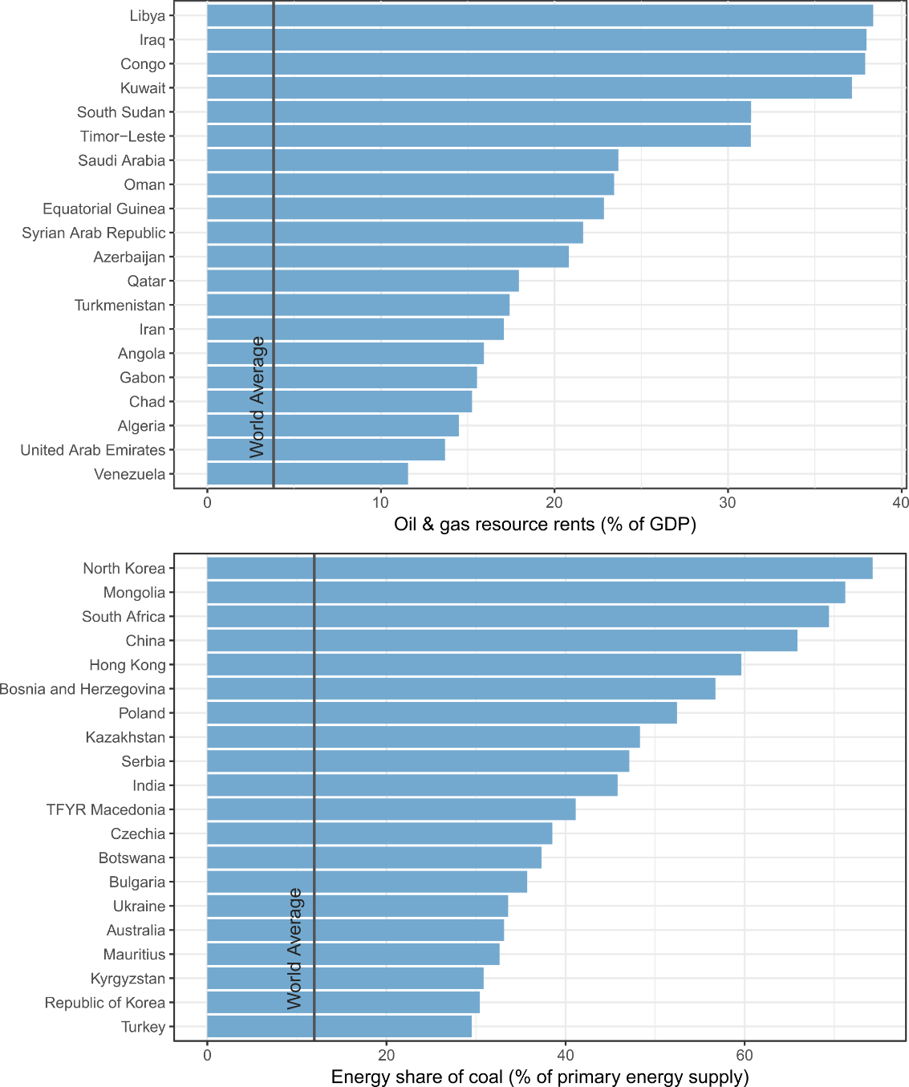

**Figure 1: 20 countries with the highest shares of oil & gas rents and coal.** Oil & gas rents are relative to GDP, coal shares are relative to primary energy supply.See section 4 for data sources.

Besides fossil fuel interests, other groups are likely to have a stake in climate policy processes. Environmental NGOs are vocal proponents and are known to support and participate in a wide array of decision making and governance activities (Kuyper, Linnér, & Schroeder, 2018). Indeed, there is cross-national evidence that the absence of environmental NGOs hinders the adoption of climate legislation (Böhmelt, Böker, & Ward, 2016; Fankhauser et al., 2015). Similarly, low-carbon industries (e.g. renewable energy producers) are an interest group that would materially benefit from climate policy. There is emerging evidence from the case study literature that they indeed support and can be decisive for the adoption of climate policies, but require nurturing through a ‘sequence’ of technology policies in order to gain an initial foothold (Meckling, Sterner, & Wagner, 2017; Pahle et al., 2018). Workers and unions are another important constituency, often vocal in opposition to reforms that result in job losses. International studies are limited, but small-n comparative research has documented heavy resistance from coal industry workers in particular, who are often well unionised and geographically concentrated, and hence can be politically influential (Spencer et al., 2018).

Fossil fuel consumers have been extensively discussed in the context of efforts to reform fossil subsidies in the global South. Fossil fuel subsidy reform renders certain consumption behaviours more expensive (e.g. household energy and vehicle use) and can have varying distributional consequences (Sovacool, 2017). In some cases, fossil fuel subsidies can primarily benefit middle and upper classes (i.e. the minority of households that have electricity and cars) - many have therefore suggested that fuel subsidies are intentionally distributed to ‘buy’ the support of politically influential constituencies (Lockwood, 2015; van Beers & Strand, 2013). In other contexts, fuel subsidies also benefit poorer households (e.g. kerosene for cooking and lighting), but are often ineffective mechanisms for poverty reduction (Rao, 2012; Sovacool, 2017). Fossil subsidy reform can therefore have varying distributional implications (Dorband, Jakob, Kalkuhl, & Steckel, 2019; Ohlendorf, Jakob, Minx, Schröder, & Steckel, 2018). Van Beers and Strand (2013) show that oil exporting countries in particular fail to limit fossil fuel subsidies, perhaps due to widespread perceptions that domestic oil resources “belong to the people” (Segal, 2012). These complexities and the direct and visible nature of subsidy benefits to consumers have rendered reform very difficult, particularly in countries with weak institutions (which limits the delivery of more targeted welfare policies) and autocratic forms of governance (which often rests on visible payments to powerful constituencies) (Lockwood, 2015; van Beers & Strand, 2013; Victor, 2009).

### Institutions

Institutions and governance arrangements have important procedural roles in the adoption and implementation of climate policies. Institutions include formal democratic systems such as elected parliaments and the distribution of powers between different ministries, as well as less formal methods of exchange and governance between public and private actors, e.g. through consultations, lobbying and so forth. Public institutions are also the primary vehicles for monitoring private sector activities and enforcing regulations, and hence have a central role in public policy implementation. Institutional analysis recognises that political struggles are mediated by these diverse arrangements, with significant consequences for the political economy of climate and environment policy (Fuchs, 2003; Lockwood et al., 2016).

To date there has been much attention on the role of democratic forms of governance, which (contra autocratic regimes) are argued to have particular features that favour the adoption of climate policy. Notably, democracies are inclusive, allowing citizens to formulate environmental values and attempt to manifest these in policies and governance (Böhmelt et al., 2016). These entitlements are reflected in the greater number of NGOs dedicated to environmental causes in democratic countries (and the absence of these in autocratic states), as well as their tolerance for a diverse and free press, which has an instrumental role in articulating policy demands and providing oversight of political activities. Such bottom-up oversight and democratic pathways of accountability are likely to be crucial to the success of the Paris Agreement, which offers no top-down international enforcement mechanism, where even the stigmatization of countries for failing to meet targets is discouraged (Karlsson-Vinkhuyzen et al., 2018).

Democratic governments also have stronger built-in incentives to provision public goods such as climate protection and basic infrastructures – e.g. health, water and sanitation – since these provide social benefits to a wide electorate on which they depend for legitimacy and support. In regimes with restricted electoral competition, political power tends to be arbitrated by a small elite (e.g. industrial oligarchs, the military, or religious figures), and incumbents know that political survival depends on funnelling government expenditures towards this elite, not towards a larger majority (Böhmelt et al., 2016; Deacon, 2009). In this manner, discussions of institutions and environmental policy often draw from an extensive literature tradition on the role of democracy in facilitating (and being mutually strengthened by) the provision of public goods (Bardhan, 2016; Deacon, 2009; Tjernström & Tietenberg, 2008).

These hypotheses are strongly supported by cross-national evidence. Higher indexes of democracy and democratic inclusiveness (e.g. strength of civil society, participation and political freedom) correlate with the adoption of climate legislation (Böhmelt et al., 2016; Lachapelle & Paterson, 2013; Obydenkova & Salahodjaev, 2017), the adoption of carbon prices (Dolphin et al., 2016; Levi et al., 2019), and the absence of fossil fuel subsidies (van Beers & Strand, 2013). Time-averaged analysis also confirms that the long-term accumulation of democratic norms and institutional apparatus is needed to support climate legislation adoption (Fredriksson & Neumayer, 2013; van Beers & Strand, 2013). In other words, even short periods of autocratic rule can leave a social and political legacy that is difficult to shake: newly democratising countries are often focused on consolidating institutions and addressing more urgent political priorities, rather than long-term climate mitigation projects.

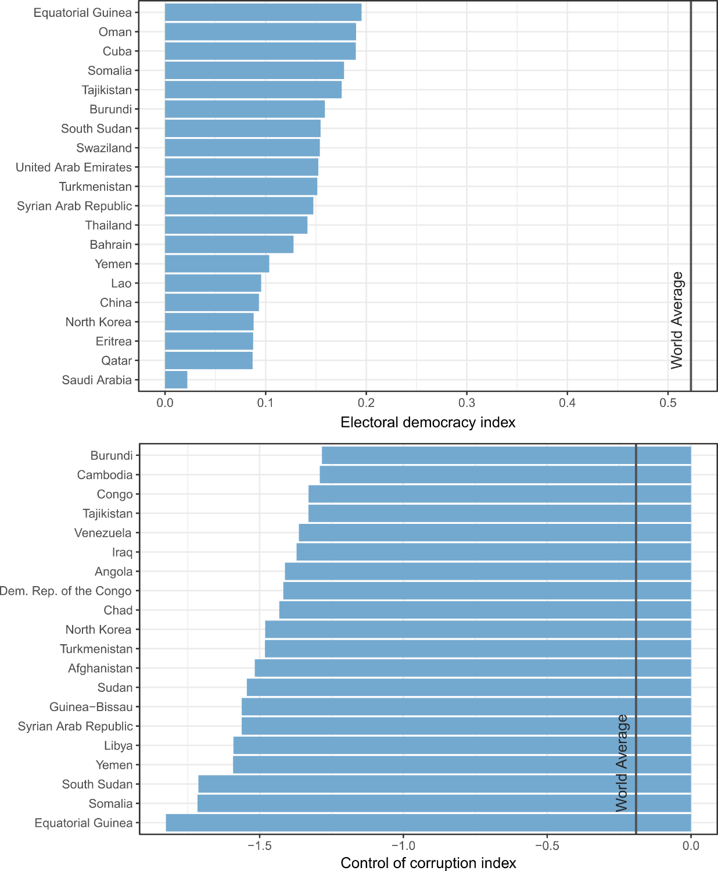

**Figure 2: 20 countries with the poorest electoral democracy and control of corruption scores.** See section 4 for data sources. The indexes are normalised between 0-1 (electoral democracy) and -2 and 2 (control of corruption).

Of course there are large differences between democracies and their institutions. A prominent claim is that the concentration of political power in centralised and parliamentary systems offers fewer frictions to climate policy adoption relative to federalist and presidential systems, which allocate power among a wider range of actors (Lockwood et al., 2016). In the latter case, a profusion of ‘veto-points’ could limit the passage of strong climate policy – for instance when regional legislatures dependent on coal mining unilaterally block national measures. There is indeed cross-national evidence that parliamentary systems are more likely to adopt climate policies (Lachapelle & Paterson, 2013), however they do not reduce emissions faster (Lachapelle & Paterson, 2013). Nor do more concentrated political systems with parliamentary majorities implement more stringent carbon prices (Levi et al., 2019). Hence there is no clear perspective on which types of democratic system are more promising.

State institutions also vary in terms of quality and exposure to corruption. In wealthier countries, bureaucracies can mobilise greater financial and human resources to formulate and implement policies. In poorer countries, states can often fail to carry out even basic functions, such as effective taxation. These conditions are often referred to as ‘state capacities’ in the institutional literature, a broad definition that encapsulates issues and indicators of “government effectiveness”, “rule of law”, and “control of corruption” (Holmberg, Rothstein, & Nasiritousi, 2009; Kaufmann & Kraay, 2015). In this context, it has been suggested that the implementation of more sophisticated climate policies (such as feed-in-tariffs) are a foregone conclusion where poor state capacities are prevalent (Jakob et al., 2014). Indeed, there are strong positive correlations between weighted carbon prices levels and subjective scores of “government effectiveness” and “regulatory quality” (see Kaufmann & Kraay, 2015), even after controlling for GDP (Levi et al., 2019)[3]. Poor control of corruption is associated with a failure to reform fossil subsidies (van Beers & Strand, 2013) and carbon tax stringency (Levi et al., 2019). In the extensive development literature, poor state capacity is linked to a wide range of public provisioning failures, such as underinvestment in health services, poor economic performance (i.e. GDP), low environmental quality (air pollution, carbon emissions), and poor human well-being outcomes (Dellepiane-Avellaneda, 2009; Easterly, Ritzan, & Woolcock, 2006; Holmberg et al., 2009; Savoia & Sen, 2015).

|  |  |  |  |  |
| --- | --- | --- | --- | --- |
| **Study** | **Dependent** | **Identified constraints and their reported effects on the adoption and stringency of climate legislation and policy**  **(+ higher value increases adoption/stringency | - decreases adoption/stringency |** 0 **no effect)** | | |
| **Interests** | **Institutions** | **Ideas** |
| (Levi et al., 2019) | **Climate policy stringency**  [Weighted carbon price level across 191 jurisdictions] | - Share of industry in GDP (+)  - Share of coal in ene. generation (-)  - Share of oil in ene. generation (0) | - Democracy index score (+)  - Government effectiveness (+)  - Control of corruption (+)  - Multilevel governance (e.g. EU) (+)  - Development level (GDP) (+)  - Political concentration (veto points) (0)  - Majoritarian voting system (0) | - High public belief in human-made climate change (+) |
| (Dolphin et al., 2016) | **Climate policy adoption**  [Carbon price adoption in 136 countries + 63 subnational jurisdictions] | - Share of industry in GDP (-)  - Share of coal in elec. generation (-)  - Share of oil in elec. generation (-)  - Share of gas in elec. generation (0)  - Share of trade in GDP (+) | - Development level (GDP) (+)  - EU membership (+)  - Democracy index score (+)  - Institutional capacity (Government effectiveness, Regulatory Quality) (0) | - Left/right political ideology (0) |
| **Climate policy stringency**  [Carbon price level across 37 countries + 24 subnational jurisdictions] | - Share of industry in GDP (-)  - Share of coal in elec. generation (-)  - Share of oil in elec. generation (0)  - Share of gas in elec. generation (0)  - Share of trade in GDP (0) | - Development level (GDP) (+)  - EU membership (+)  - Institutional capacity (Government effectiveness, Regulatory Quality) (0) | - Left/right political ideology (0) |
| (Fankhauser et al., 2015) | **Climate legislation adoption**  [Targets and policies within a given year across 63 national jurisdictions] | - Pro-green lobby (IUCN members) (+)  - Share of fossil/mining exports in GDP (0) | - Existing legislation and path dependency (e.g. presence of flagship laws) (+)  - Electoral cycles (strong democracies) (-)  - Electoral cycles (weak democracies) (0)  - Concentration of political power (seat shares of ruling party in all legislatures) (+) | - Right-political ideology (Anglo-Saxon countries (-)  - Left/right political ideology (all countries) (0) |
| (Böhmelt et al., 2016) | **Climate legislation adoption**  [UNFCCC protocols + emissions across 149 national jurisdictions] | - Pro-green lobby (IUCN members) (+) | - Political participation (freedom of speech, assembly, association) (+)  - Political freedoms (suffrage, elections, women’s political rights) (+) |  |
| (Lachapelle & Paterson, 2013) | **Climate policy adoption**  [Adoption of regulations, incentives, carbon price, voluntary agreements, R&D across 19 countries] | - Fossil fuel exports (-) | - Democratic Polity score (+)  - Parliamentary system (+)  - Variety of capitalism affects instrument choice (0)  - Proportional representation (0) |  |
| (Fredriksson & Neumayer, 2013) | **Climate legislation adoption**  [CLIMI Index for 87 countries] |  | - Years of democracy, with depreciation during autocracy (+)  - Constraints on the executive (e.g. independent judiciary) (+)  - Political competition (free and fair elections) (0) |  |
| (Obydenkova & Salahodjaev, 2017) | **Climate legislation adoption**  [CLIMI Index for 94 countries] | - CO2 per capita (-) | - Democracy index score (+) | - Social cognitive capital (IQ) (+) |
| (Steves & Teytelboym, 2013) | **Climate legislation adoption**  [CLIMI Index for 73 countries) | - CO2 per GDP (-)  - CO2 per capita (-)  - Share of industry, mining, utilities in GDP (-) | - Democracy Polity score ( 0 controlling for public knowledge, CO2 per capita and Kyoto commitments)  - Government effectiveness & regulatory quality ( 0 controlling for public knowledge, CO2 per capita and Kyoto commitments)  - EU membership (+)  - Post communist (0) | - Public knowledge of climate change (+) |
| (van Beers & Strand, 2013) | **Climate policy adoption (fossil fuel subsidy reform)**  [Petrol and diesel prices for 201 countries] | - Oil export surplus (-) | - Development level (GDP) (+)  - Control of corruption (+)  - Years of democracy (+)  - Shift to democracy (- then +)  - Presidential system (-)  - Proportional representation (+)  - Concentration of political power (seat shares of ruling party) (-) |  |

**Table 3: Cross-national studies of political economic constraints to climate policy**. Note: in some cases we do not report variables outside the interest/institution/ideas typology. Often these are control variables such as the share of trade in GDP (Böhmelt et al., 2016).

### Ideas

Climate policy has long been a battle of ideas, with much contestation centred on the perceived existence, severity and human-driven nature of climate change. Many have reasoned that if the public remains in doubt regarding the causes and impacts of climate change, then legislators will be unwilling to push for climate policy adoption (Drews & van den Bergh, 2016; Lee, Markowitz, Howe, Ko, & Leiserowitz, 2015). Indeed, public belief in climate change to a large extent explains willingness-to-pay for climate policies in a US survey (Kotchen, Boyle, & Leiserowitz, 2013).

There is an extensive literature examining the underlying drivers of climate change perceptions. Much attention is paid to left- versus right-leaning political orientations, which appear to correlate with positive and negative attitudes, respectively, on climate change belief, concern, and preference for policies (Drews & van den Bergh, 2016; Ziegler, 2017). However, it could be that the phenomenon of conservative climate scepticism is unique to Anglo-Saxon countries (US, UK, Canada and Australia), all of which are highly exposed to organised networks of climate scepticism and misinformation (Farrell, 2016; Farrell, McConnell, & Brulle, 2019; Lewis, Palm, & Feng, 2018; Painter, 2011). Again, this underlines the manifold channels by which interests can intentionally hinder climate policy (Oreskes & Conway, 2010).

In broader cross-national studies, education emerges as the most significant predictor of climate change awareness and risk perception (Lee et al., 2015; Lewis et al., 2018), followed by media freedom (Steves & Teytelboym, 2013). Accordingly, countries with poor education provisioning and media landscapes that fail to prioritise climate reporting can have majority populations that are simply unaware of climate change, as is the case in India, Bangladesh, Egypt and Nigeria (Lee et al., 2015) (see Figure 3). Climate change awareness is in turn a significant determinant in cross-national regressions of weighted carbon prices (Levi et al., 2019) and climate legislation adoption (Steves & Teytelboym, 2013). Of course, here there is a particularly strong case for reverse causality, insofar as climate policy formulation is likely to increase public awareness of the problem. In short, public opinion on climate change (awareness, belief, risk perception) matters for policy making, and it can be bolstered by education and media, or weakened by propaganda (see Burstein, 2011 for a general review).

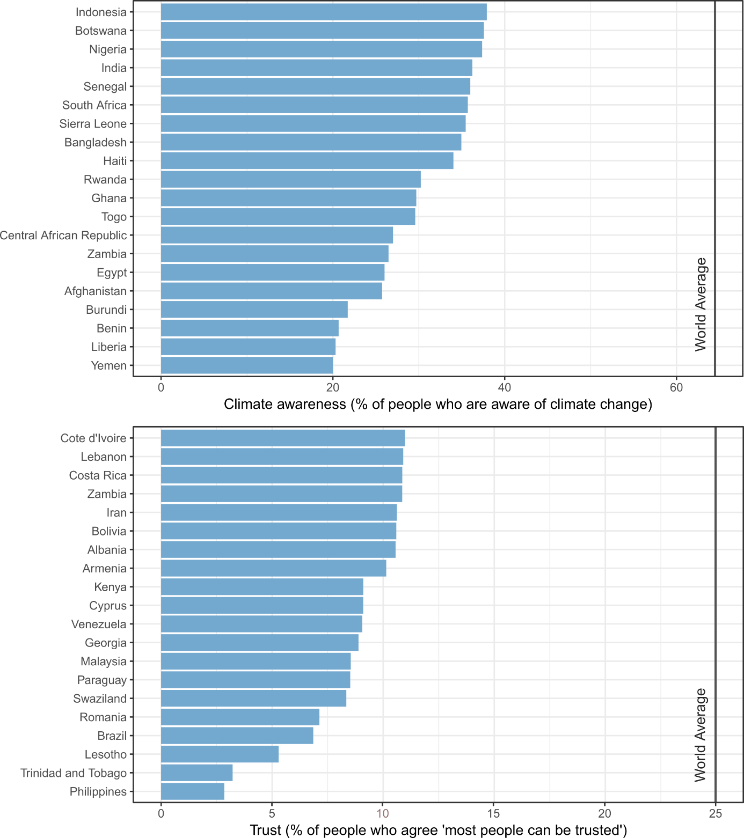

**Figure 3: 20 countries with the lowest levels of climate awareness and social trust.** Data are based on representative surveys, see section 4 for sources.

Trust is another key element of national ideational context that shapes climate policy support. It is the notion that other individuals, institutions, scientists, or politicians share common social norms and act in a mutually beneficial way (Drews & van den Bergh, 2016; Smith & Mayer, 2018). A lack of trust in institutions implies limited confidence that public policies and environmental measures will be effective (Harring, 2014). A lack of social trust (e.g. in others generally) undermines collective action, since few will have the confidence that others are ‘doing their part’. In a small-n comparative study, Smith and Mayer (2018) find that individuals with high levels of social and institutional trust are far more willing to support costly climate policies. Hammar and Jagers (2006) find a similar result for trust in politicians in Norway, while Fairbrother (2016) extends the analysis to an international survey, showing a consistent and positive pattern of trust in explaining environmental policy support. Against a backdrop of low or progressively eroding trust in social and political institutions (see Figure 3), and the emergence populist parties and agendas that dismiss climate concerns (Lockwood, 2018), this is a problem that has likely not received the attention it deserves (Fairbrother, 2017).

### Towards architectures of constraints

Most studies agree that strong institutions, democratic governance and public support are needed to put in place effective climate policies. But by the same token, vested interests can actively undermine these conditions, underlining the interrelated nature of constraints. And yet cross-national studies tend not to focus on inter-dependencies, but rather focus on individual effects. The result is generic policy advice calling for calling for “establishing an enabling environment” or “building technical and institutional capacity” (Carbon Pricing Leadership Coalition, 2017). But if constraints occur simultaneously within countries, and have strong interlinking causal mechanisms, then the task of overcoming them becomes rather more difficult. How can institutions be reformed, when the necessary conditions for doing so – technocratic skill, or sheer political will – are absent and or even endogenous to their failure (Easterly et al., 2006)? Arguably, one would then need to deal with *architectures of constraints* that are deliberate in nature, enduring over time, and actively defended by interest groups (Chayes, 2017).

The literature on the ‘resource curse’ is enlightening in this regard. It follows the empirical phenomenon that states with considerable natural resource endowments tend to experience wide-ranging detrimental effects on their societies and institutions (Ross, 2015; van der Ploeg, 2011). There is strong evidence in particular that an abundance of oil increases the durability of authoritarian rule and heightens levels of corruption. That is, a distinct architecture can be seen in countries at the upper end of the spectrum of oil production (e.g. Algeria, Iran, Saudi Arabia, Qatar and others), of which not a single has successfully become democratic since 1960 (Ross, 2015). Often these are referred to as ‘rentier states’, where oil revenues are used to reduce taxes, increase patronage, and fund a military/security apparatus – all effective means for incumbent rulers to buy off challengers and suppress dissent. Oil rents also provide multiple avenues for local enrichment and corruption, providing that prior institutions are weak enough to facilitate such activities (van der Ploeg, 2011). With regime stability resting upon these systems of corruption, one should not be naïve about the prospects for reform (Chayes, 2017).

Failed and fragile states are another problematic architecture for climate policy adoption. Clearly, countries in the midst of civil wars (Syria, Iraq, Libya, Yemen) or major domestic instability (Venezuela) cannot progress energy and climate policies (Griffiths, 2017). Such events also spill over into neighbouring countries through mass migration and conflicts. These might be considered one-off ‘exogenous shocks’ sparked by specific events, and yet underlying structural conditions often provide the tinder. Failing state institutions, the under-provisioning of basic needs, and latent ethnic or political tensions can all be leveraged to realise political or economic gains by interest groups (Alesina, Devleeschauwer, Easterly, Kurlat, & Wacziarg, 2003; Easterly et al., 2006). Such conditions can be mutually dependent (Sen, 1999) and often have strong historical origins (e.g. colonialism) (Acemoglu, Johnson, & Robinson, 2001). Again, this renders generic advice to increase competencies and build an ‘enabling environment’ rather hollow. As of 2019, 38 countries and territories can be found on the World Bank list of fragile situations[4].

In the analysis of climate policy progress, little work has comprehensively explored architectures of political, economic and social constraints. A notable exception is the case study by Sarah Chayes (2017) on the interconnected roles of public and private actors in Honduras; a system of corruption that extracts rents by design and actively prevents systemic change. As a first step towards understanding such architectures, in the next section we elaborate on some basic stylized facts.

### Stylized facts

Which of the discussed constraints are interrelated? In which countries do they cluster? And what are their trends over time? Here we assemble a dataset of indicators representing different constraint dimensions, then explore their interrelations and distribution across different countries of the world.

### Materials and Methods

### Data

We structure the data around four categories: dependent variables of climate policy progress, and constraints related to interests, institutions and ideas (Table 4). Our indicator selection largely follows the studies reviewed in section 3, but is highly moderated by the quality and availability of data for a relatively complete set of countries.

In the first instance, we select three measures of climate policy progress: climate legislation adoption (Grantham Institute, 2017), the on-going prevalence of fossil fuel subsidies (calculated by Coady et al., 2019), and territorial carbon emissions (Quéré et al., 2018). While the latter measure is conceptually limited (as discussed in section 2.2), there are such wide differences in the mitigation challenge between countries (a factor of 15-20 in some cases) that it provides important context for our analysis. For legislation adoption, we remove purely adaptation-focused laws due to our mitigation focus here. For fossil fuel subsidies, we use the pre-tax subsidy level, which estimates the difference between fuel supply costs and consumer prices. This is a relatively narrow measure that does not reflect the full external costs of fossil fuel use, such as those from air pollution and climate damages (Coady et al., 2017).

Following the discussion, we select two measures of interest-based constraints. First, the fraction of coal in the energy generation mix is clearly relevant – we construct this indicator from IEA data (2018a). We also see the presence of oil and gas extraction as a key constraint, due to the documented tendency of this industry to dominate national economies and limit state capabilities. We represent this by summing the World Bank (2017) indicators for oil and gas resource rents – i.e. national net earnings from these industries as a fraction of GDP.

|  |  |  |  |  |
| --- | --- | --- | --- | --- |
| **Variable** | **Name** | **Unit** | **Latest year** | **Source** |
| **Dependents** | | | | |
| Climate legislation adoption | Climate laws | No. laws per country | 2017 | (Grantham Institute, 2017) |
| Fossil fuel subsidies | Fossil subsidies | Pre-tax subsidy as % of GDP | 2017 | (Coady et al., 2019) |
| CO2 emissions (territorial) | CO2 emissions | tCO2 per capita | 2017 | (Quéré et al., 2018) |
| **Interests** | | | | |
| Oil & gas rents | Oil & gas rents | Rents as % of GDP | 2015 | (World Bank, 2017) |
| Coal in elec. mix | Coal share | % of coal in total primary energy supply | 2014 | (IEA, 2018a) |
| **Institutions** | | | | |
| Electoral democracy index | Democracy | 0 – 1.0 (normalised scale) | 2015 | (V-DEM, 2018) |
| Control of corruption | Corruption | -2.0 – 2.0 (normalised scale) | 2017 | (Kaufmann & Kraay, 2015) |
| **Ideas** | | | | |
| Social trust | Trust | % of population who trust others | 2017 | (WVS, 2014) |
| Climate awareness | Climate awareness | % of population aware of climate change | 2010 | (Lee et al., 2015; Pelham, 2009) |

**Table 4: Data and variables**

Institutional variables are well documented and widely available. Given considerable evidence pointing to the importance of broad democratic processes, as well as the specific issue of controlling corruption, we employ respective indexes on these dimensions from the V-Dem (2018) and World Governance Indicator (Kaufmann & Kraay, 2015) databases.

Finally, for idea-based constraints we centre on climate change awareness and social trust as the foundations for long-term public policy making. The former we obtain from the Gallup survey of 2008 (Pelham, 2009), averaged with data reported in a more recent publication (Lee et al., 2015). The latter was obtained by aggregating the World Values Survey (WVS, 2014) with regional value surveys from Europe, Latin America and Africa.

### Correlations, PCA, cluster and trend analysis

Our exploratory analysis consists of 4 stages. First we calculate the (Spearman) correlations between variables, to derive a general sense of the dominant relationships at hand. Second, we perform a principal component analysis (PCA) to synthesize the dataset into a smaller set of dimensions. Since we expect strong correlations between certain variables (for instance, democracy and corruption), PCA reduces the raw data into vectors (components) that combine these effects, each orthogonal to the other, capturing decreasing amounts of variance. This aids interpretation, by removing noise, and creates more stable data for conducting cluster analysis (Husson, Lê, & Pagès, 2017). Third, we perform cluster analysis using a k-means algorithm on the principal components that account for 85% of the cumulative data variance. The number of clusters is subjectively chosen: we calculated n clusters from 4 to 8, and noted that beyond 5 we obtain only marginal differentiation between groups of wealthier northern states. The 5 clusters of countries are then descriptively analysed and named. In this combination of PCA and clustering methods we follow a simplified version of the approach by Cahen-fourot (2019), which explores varieties of national capitalism and their social relation to the environment. Finally, we assess general trends over time by country and cluster.

Due to the high data requirements of this analysis we use the latest available years for each variable (see Table 4). However, for some countries there simply is no data on key variables, particularly in the case of climate awareness, trust and coal use. We are therefore only able to capture 99 countries in the final cluster analysis, representing 88% of global population and 92% of global emissions. The main data gaps are found in sub-Saharan Africa.

### Results

### Interrelations between constraints

Figure 4 shows a striking (but not unexpected) picture: the continued existence of fossil fuel subsidies is strongly and negatively correlated with control of corruption, electoral democracy, awareness of climate change, and to a lesser extent, levels of social trust. The adoption of climate legislation, in turn, is positively associated with these indicators. In the principal component analysis, we see much of these trends captured in the first component: where institutional and idea-based constraints are closely linked to subsidy removal and the adoption of climate legislation. We interpret this as a latent ‘development’ variable that points to a general North-South divide in the quality of public institutions, with knock-on impacts on the social sphere and climate policy constraints.

Are territorial carbon emissions also associated with these constraints? Evidently, the correlations suggest that nations with stronger institutions and a more supportive social sphere for policies (e.g. wealthier countries) do tend to have higher emissions. Yet in the second principal component, emissions is a dominant variable, associating primarily with oil & gas rents and social trust. Hence there is likely a well-differentiated subset of fossil-extractive nations in which emissions are very high. Such emissions may arise from extraction processes themselves (which tend to be energy-intensive), or from poor incentives to pursue efficiency and fuel switching measures, i.e. a ‘fossil-resource curse’ (Friedrichs & Inderwildi, 2013). Again, in such contexts, the adoption of climate legislation becomes less likely.

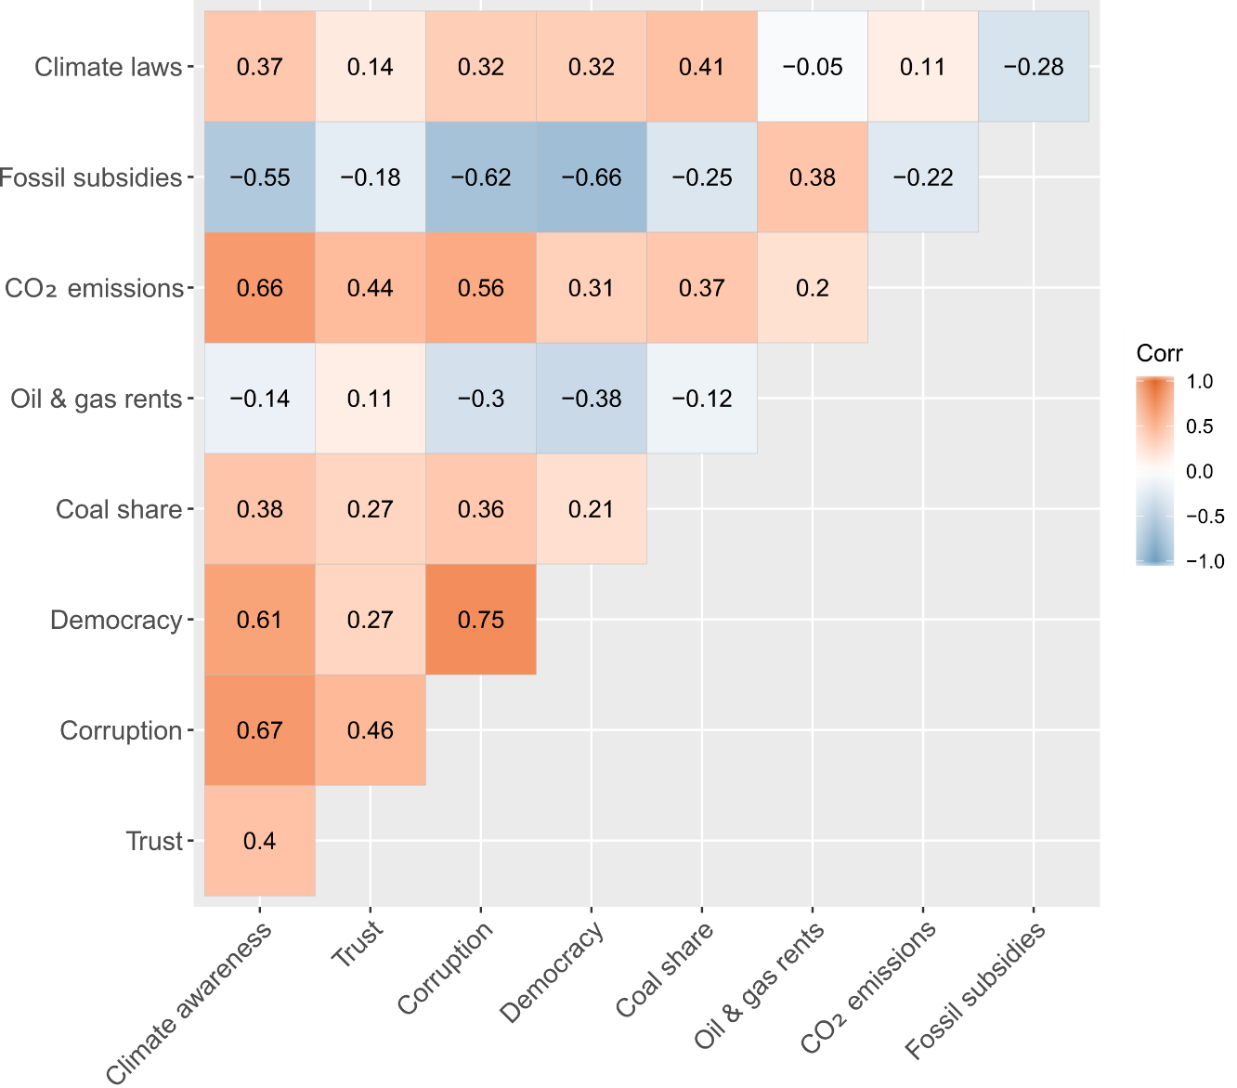

**Figure 4: Spearman correlations**

The influence of coal is interesting: it moderately correlates with institutional variables and legislation adoption, but negatively with fossil subsidies. This suggests that coal share does not provide a significant barrier at the legislative level. Yet the low strength of these relationships, and the third principal component (which is primarily driven by this measure), indicates that coal share is orthogonal to other constraints: cutting across different types of countries, and in certain contexts associating negatively with the measure of electoral democracy.

Overall, the low variance captured by each component suggests that political economic constraints are rather heterogeneous. They are captured in a few general trends that we have described, but there is much room for context-specific combinations of factors.

|  | **PC1** | **PC2** | **PC3** | **PC4** | **PC5** |
| --- | --- | --- | --- | --- | --- |
| SD | 1.85 | 1.29 | 1.02 | 0.88 | 0.85 |
| Proportion of variance | 0.38 | 0.18 | 0.12 | 0.09 | 0.08 |
| Cumulative variance | 0.38 | 0.56 | 0.68 | 0.77 | 0.85 |
| Climate laws | **0.27** | **0.27** | **0.28** | **-0.73** | **-0.28** |
| Fossil subsidies | **-0.35** | -0.20 | 0.14 | **-0.27** | **-0.45** |
| CO2 emissions | 0.22 | **-0.60** | 0.06 | -0.17 | **0.37** |
| Oil & gas rents | -0.24 | **-0.58** | -0.12 | **-0.27** | 0.09 |
| Coal share | 0.17 | -0.02 | **0.87** | 0.19 | **0.27** |
| Democracy | **0.42** | 0.19 | **-0.29** | -0.01 | 0.16 |
| Corruption | **0.48** | -0.12 | -0.15 | 0.15 | -0.16 |
| Trust | **0.30** | **-0.35** | 0.11 | **0.37** | **-0.67** |
| Climate awareness | **0.42** | -0.14 | -0.11 | **-0.32** | 0.06 |

**Table 5: Principal component analysis of constraints**

### Clusters of countries

Where do similar types of constraint manifest? We estimate 5 groups of countries in the cluster analysis, implicitly ordered from highest to lowers apparent constraints (Figure 5). We first observe a group of states strongly dependent on oil & gas resource extraction. Of the entire sample, these tend to have the lowest levels of legislation adoption, the highest fossil subsidies, as well as the most serious deficiencies in controlling corruption and advancing democratic norms. In short they appear to face fundamental political economic barriers to advancing climate policy. The states include countries such as Saudi Arabia, Iran, Algeria and Venezuela[5]. They comprise 6% of global emissions (territorial) and 5% of global population.

The second cluster we name ‘fragile states’. These are countries which tend to lack democratic norms, have poor levels of corruption control, and limited social trust. They have made little progress in climate legislation adoption and fossil subsidy removal, but generally have low levels of per capita carbon emissions. The fragile states group includes many low-income countries in Africa, Latin America and Asia such as Nigeria, Mexico, Pakistan, Bangladesh and Kenya. They make up 3% of global emissions and 11% of global population.

The third cluster is primarily distinguished by a heavy reliance on coal in primary energy supply. We refer to this group as ‘coal dependent development’, since it captures fast emerging economies such as China, India, Turkey, South Africa, Russia, as well as other countries from the former Soviet Union and Eastern Block. This group tends to occupy the middle-ground of political economic constraints: moderate legislation adoption and emissions, some remaining fossil subsidies, but institutions that are fragile and exposed to corruption. However, there is diversity and a large spread of values across different dimensions, from autocratic regimes to competitive electoral democracies, as well as low and high levels of trust and awareness. This group makes up the largest share of global emissions (47%) and population (48%).

The fourth cluster of countries has the highest average rates of climate legislation adoption; they also have relatively low carbon emissions and very limited fossil subsidies. We call this group ‘fractured democracies’ since they have formal electoral systems, but remain hampered by low levels of trust and a failure to eradicate corruption. It is a group of middle and upper-middle income countries in Latin America and Eastern Europe, among which the awareness of climate change is typically high. Countries such as Brazil, Argentina, Chile, Portugal, Greece and Hungary are present in this cluster. It comprises 4% of global emissions and 6% of the global population.

The final cluster is dominated by wealthy OECD nations, where emissions are high and direct fossil subsidies are practically eliminated. These countries have moderate (but not high) levels of trust, a good awareness of climate change, and strong democratic institutions largely free from corruption. With the lowest apparent levels of constraints, they ought to be leading in climate policy ambition, and yet legislation adoption is spread across a large range, averaging lower than the fourth cluster. In this sense the group is lagging in its potential progress. Indeed some known examples, such as the United States, Australia and Canada, have backtracked on climate policies amid strong lobbying and domestic opposition. This group is responsible for 30% of global emissions and 13% of global population.

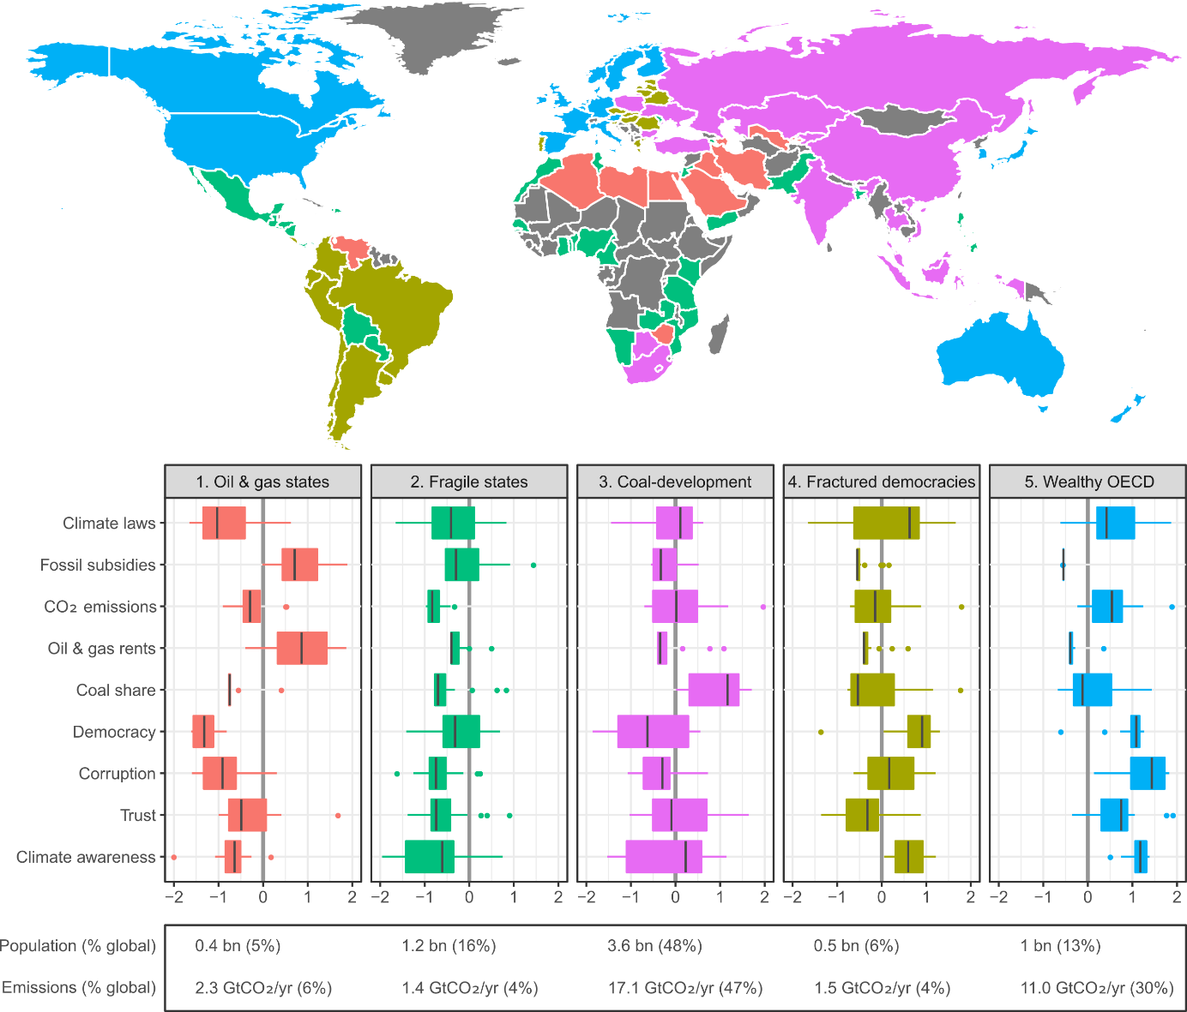

**Figure 5: Clusters of constraints across countries.** Population and emissions for each cluster are shown, but are not used as variables in the cluster analysis.

### Trends in constraints

How have political economic constraints developed over the past decades? Figure 4 depicts these trends where data is available. Most striking is the level of stability in perceived corruption since the 1990s. In fact, for a large portion of the sample we see evidence of marginal declines, even among countries in the wealthy OECD group, such as the USA, UK and Italy. Democratic institutions have fared somewhat better, particularly in the cluster of ‘fragile states’. Nigeria, for example, has made large improvements. However in some countries, democratic norms (or the lack thereof) have remained highly stable. This is the case in China, and the majority of oil & gas states. In some circumstances democratic quality has substantially declined (Russia, Venezuela).

Oil & gas rents have noticeably increased among oil & gas states over the past two decades, with only isolated instances of decline (e.g. Yemen). The share of coal in primary energy supply has also increased across most of the ‘coal-dependent development’ group, but is mainly driven by India and China. This trend has been well documented in the climate literature (Steckel, Edenhofer, & Jakob, 2015). Indeed, there remains a large pipeline of planned and under-construction coal power plants, particularly in India, Turkey, Vietnam and Indonesia (Edenhofer, Steckel, Jakob, & Bertram, 2018).

The main intuition here is that one cannot rely on underlying political economic constraints to naturally improve over time, not even as countries industrialise and gain wealth. In the case of democracy, highly stable non-democratic regimes exist. These may be fully autocratic systems with no electoral possibilities, such as in Saudi Arabia; or hybrid regimes that combine democratic elements with corruption and autocratic rule, such as in Russia (Levitsky & Way, 2002; V-DEM, 2018). In a similar sense, the other categories of constraint are not necessarily in a positive transition, but must be actively addressed and improved.

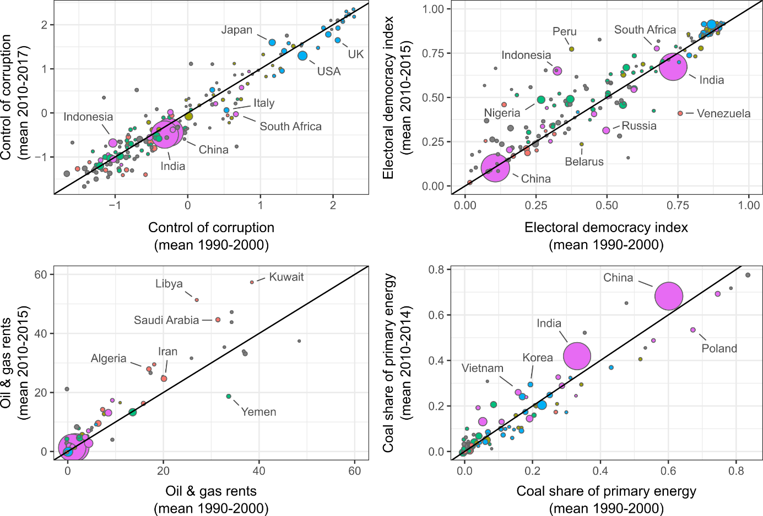

**Figure 6: trends in constrains by cluster.** Data points scaled to country population. Not all constraints shown, due to insufficient time spans in the data.

There are some limitations with this analysis. First, the international scope raises data limitations. As we have discussed in this paper, there are few adequate cross-national measures of climate policy performance. At best, the number of climate laws implemented in a country gives a suggestion of policy engagement, but does not describe policy quality or ambition. The inclusion of fossil subsidies and current emissions gives a more rounded picture, but one that is still lacking. Quantifying interest-based opposition to climate policy is also challenging: both oil & gas rents and shares of coal tend to describe supply-side issues. They do not capture issues concerning transportation, agriculture or energy demand. Nor can they describe the full scope of possible lobbying and obstruction activities through political capture. The fact that the United States is categorised into the least constrained group of countries attests to this problem. Finally, the data on climate awareness is notably out of date. Climate awareness and concern may rapidly change, due to political circumstances (e.g. the Paris Agreement) or extreme-weather events; however we are aware of no recent cross-national surveys that have documented such shifts.

Methodological limitations should also be noted. Cluster analysis is primarily a heuristic device to understand broad categorisations: it does not account for the magnitude of effects in each dimension (for instance, democratic norms may be more consequential than climate awareness) There is also an inevitable trade-off between the number of clusters (affecting interpretability) and the quality of each cluster (i.e. internal variation along each dimension). Nonetheless, this work provides a descriptive starting point and raises critical questions for future research.

### Discussion & conclusion

In this paper we set out to explore political economic constraints to climate policy. We take a comparative focus at the national level, categorising interest, institution and idea-based constraints that actively hinder the advancement of climate policy. We argue that it is possible to document and explore systematic differences in these constraints between countries. However, this comes with major conceptual and empirical challenges going forward.

First, our study finds very little structured understanding of how to compare national climate policy progress, including what dependent variables can be put to this task. This is a major limitation, not only for examining political economic constraints, but in broadly documenting the performance of countries. Research tends to focus on individual facets of progress, such as target setting (the NDCs), tracking emissions trends, or estimating implicit carbon prices. Thus if a government claims to be a world leader in climate policy ambition, it is genuinely difficult to assess such a claim. Work is needed to bridge this gap and build multi-dimensional criteria and measures that can shine a critical light on national climate policy progress. This could pave the way for more rigorous and policy-relevant assessments of the prevalent climate policy gap.

Second, the extant literature documents a series of constraints. Oil and gas extraction activities and supply-side fossil penetration both appear to hinder decarbonisation. Undemocratic and more corrupt countries fare poorly in the adoption of climate legislation and policies. Low levels of climate awareness and social trust are further barriers. And besides these, a host of more nuanced and less easily traced factors are likely to hold influence, such as dominant political ideologies, legalised forms of corruption (lobbying), institutional designs that offer veto-points, demand-side carbon lock-in, and so forth.

Third, we claim that such constraints are likely to be inter-related and mutually reinforcing in some circumstances – perhaps hinting at more fundamental architectures of constraint. This is scarcely researched territory in the context of climate policy. It has rather gained attention where regimes actively facilitate resource extraction, economic exploitation and kleptocratic tendencies, such as in rentier and fragile states.

Finally, we conduct an empirical analysis of constraints, focusing on some basic stylized facts. The available data demonstrates strong interrelations, with several dominant trends captured in a vector of institutional strength (democracy, control of corruption), implicit social support for policy (climate awareness, social trust), and an absence of fossil extraction activities and subsidies. Cluster analysis establishes 5 groups of countries. Of these, the oil states appear to be most fundamentally hindered in climate policy progress, due to dominant interest-based opposition and undemocratic institutional regimes. Indeed, strong democratic norms and institutions free from corruption are a rarity, coalescing in only one cluster of countries, the wealthy OECD group. That these constraints are stable over time, or in many cases declining (social trust) is a cause for significant concern, given the already pressing challenge of remaining within dwindling carbon budgets.

It is important to have a clear-eyed view of these challenges. The typical advice following analysis of this kind is that our attention should focus on establishing ‘enabling environments’ for climate policy. Yet, as others have argued, one cannot simply mobilise political will and technocratic skill when these ingredients are purposefully absent (Chayes, 2017). What then, are realistic intervention points? This is a question that deserves our attention. Recent literatures argue for a shift beyond standard economic theories of policy instrument choice, which has traditionally promoted carbon taxation across all regions and sectors. Instead, a sequencing of different policy instruments with growing ambition appears more realistic to overcome the various constraints in a stepwise process (Meckling et al., 2017; Pahle et al., 2018).

The active formation of political movements and building of climate constituencies appears critical. Beyond policy sequencing, this might involve diverse approaches from raising legal cases, establishing boycotts, and challenging finance (Galaz et al., 2018), to building anti-fossil norms (Green, 2018). Progress on these fronts might be propagated through international institutions and diplomatic pressure. It may require building unusual alliances, bringing together democratic movements and climate advocacy. And it certainly requires increasing ambition and actions within countries that face lower comparative challenges. This may result in international spill-overs from a decline in fossil fuel demand, and the steady development of alternative technologies. Above all, the underlying reasons for our continued failure to shift towards a global low-carbon transition need to be brought to light.

### References

Acemoglu, D., Johnson, S., & Robinson, J. A. (2001). The Colonial Origins of Comparative Development : An Empirical Investigation. *The American Economic Review*, *91*(5), 1369–1401.

Alesina, A., Devleeschauwer, A., Easterly, W., Kurlat, S., & Wacziarg, R. (2003). Fractionalization. *Journal of Economic Growth*, *8*, 155–194.

Bache, I., Reardon, L., Bartle, I., Flinders, M., & Marsden, G. (2015). Symbolic Meta-Policy: (Not) Tackling Climate Change in the Transport Sector. *Political Studies*, *63*(4), 830–851. https://doi.org/10.1111/1467-9248.12123

Baker, L., Newell, P., & Phillips, J. (2014). The Political Economy of Energy Transitions: The Case of South Africa. *New Political Economy*, *19*(6), 791–818. https://doi.org/10.1080/13563467.2013.849674

Bardhan, P. (2016). State and Development: The Need for a Reappraisal of the Current Literature. *Journal of Economic Literature*, *54*(3), 862–892. https://doi.org/10.1257/jel.20151239

Bernauer, T., & Böhmelt, T. (2013). National climate policies in international comparison: The Climate Change Cooperation Index. *Environmental Science and Policy*, *25*, 196–206. https://doi.org/10.1016/j.envsci.2012.09.007

Böhmelt, T., Böker, M., & Ward, H. (2016). Democratic inclusiveness, climate policy outputs, and climate policy outcomes. *Democratization*, *23*(7), 1272–1291. https://doi.org/10.1080/13510347.2015.1094059

Burck, J., Hagen, U., Marten, F., Höhne, N., & Bals, C. (2019). *Climate Change Performance Index 2019*. Bonn. Retrieved from https://www.climate-change-performance-index.org/the-climate-change-performance-index-2019

Burstein, P. (2011). The Impact of Public Opinion on Public Policy: A Review and an Agenda. *Political Research Quarterly*, *56*(1), 29–40. https://doi.org/10.1177/106591290305600103

Cahen-fourot, L. (2019). *The social relation to the environment in contemporary capitalism: theoretical reflections and empirical explorations* (No. 26). Vienna.

Carbon Pricing Leadership Coalition. (2017). *Report of the High-Level Commission on Carbon Prices*.

Chayes, S. (2017). *When corruption is the operating system: the case of Honduras*. Washington, DC.

Coady, D., Parry, I., Le, N., & Shang, B. (2019). *Global Fossil Fuel Subsidies Remain Large: An Update Based on Country-Level Estimates* (19 No. 89). Washington, D.C. Retrieved from https://www.imf.org/en/Publications/WP/Issues/2019/05/02/Global-Fossil-Fuel-Subsidies-Remain-Large-An-Update-Based-on-Country-Level-Estimates-46509

Coady, D., Parry, I., Sears, L., & Shang, B. (2017). How Large Are Global Fossil Fuel Subsidies? *World Development*, *91*, 11–27. https://doi.org/10.1016/j.worlddev.2016.10.004

Compston, H., & Bailey, I. (2016). Climate policy strength compared: China, the US, the EU, India, Russia, and Japan. *Climate Policy*, *16*(2), 145–164. https://doi.org/10.1080/14693062.2014.991908

Creutzig, F., Agoston, P., Minx, J. C., Canadell, J. G., Andrew, R. M., Quéré, C. Le, … Dhakal, S. (2016). Urban infrastructure choices structure climate solutions. *Nature Climate Change*, *6*(12), 1054. https://doi.org/10.1038/nclimate3169

Crowley, K. (2017). Up and down with climate politics 2013–2016: the repeal of carbon pricing in Australia. *Wiley Interdisciplinary Reviews: Climate Change*, *8*(e458). https://doi.org/10.1002/wcc.458

Davis, S. J., & Socolow, R. H. (2014). Commitment accounting of CO2 emissions. *Environmental Research Letters*, *9*(8), 084018. https://doi.org/10.1088/1748-9326/9/8/084018

Deacon, R. T. (2009). Public good provision under dictatorship and democracy. *Public Choice*, *139*(1–2), 241–262. https://doi.org/10.1007/s11127-008-9391-x

Dellepiane-Avellaneda, S. (2009). Review Article: Good Governance, Institutions and Economic Development: Beyond the Conventional Wisdom. *British Journal of Political Science*, *40*(01), 195. https://doi.org/10.1017/S0007123409990287

Dietz, T. (2017). Drivers of Human Stress on the Environment in the Twenty-First Century. *Annual Review of Environment and Resources*, *42*, 189–213. https://doi.org/10.1146/annurev-environ-110615-085440

Dolphin, G. G., Pollitt, M. G., & Newbery, D. G. (2016). *The Political Economy of Carbon Pricing: a Panel Analysis* (Cambridge Working Paper Economics No. 1663). Cambrdige, UK. https://doi.org/10.17863/CAM.7825

Dorband, I. I., Jakob, M., Kalkuhl, M., & Steckel, J. C. (2019). Poverty and distributional effects of carbon pricing in low- and middle-income countries – A global comparative analysis. *World Development*, *115*, 246–257. https://doi.org/10.1016/j.worlddev.2018.11.015

Drews, S., & van den Bergh, J. C. J. M. (2016). What explains public support for climate policies? A review of empirical and experimental studies. *Climate Policy*, *16*(7), 855–876. https://doi.org/10.1080/14693062.2015.1058240

Easterly, W., Ritzan, J., & Woolcock, M. (2006). *Social Cohesion, Institutions, and Growth* (No. 94).

Edenhofer, O., Steckel, J. C., Jakob, M., & Bertram, C. (2018). Reports of coal’s terminal decline may be exaggerated. *Environ. Res. Lett*, *13*, 1–9. https://doi.org/10.1088/1748-9326/aaa3a2

Fairbrother, M. (2016). Trust and public support for environmental protection in diverse national contexts. *Sociological Science*, *3*, 359–382. https://doi.org/10.15195/v3.a17

Fairbrother, M. (2017). Environmental attitudes and the politics of distrust. *Sociology Compass*, *11*(5), 1–10. https://doi.org/10.1111/soc4.12482

Fankhauser, S., Gennaioli, C., & Collins, M. (2015). The political economy of passing climate change legislation: evidence from a survey. *Global Environmental Change*, *35*, 52–61. https://doi.org/10.1016/j.gloenvcha.2015.08.008

Farrell, J. (2016). Network structure and influence of the climate change counter-movement. *Nature Climate Change*, *6*(4), 370–374. https://doi.org/10.1038/nclimate2875

Farrell, J., McConnell, K., & Brulle, R. (2019). Evidence-based strategies to combat scientific misinformation. *Nature Climate Change*, *9*(March), 191–195. https://doi.org/10.1038/s41558-018-0368-6

Foxon, T. J., Pearson, P. J. G., Arapostathis, S., Carlsson-Hyslop, A., & Thornton, J. (2013). Branching points for transition pathways: assessing responses of actors to challenges on pathways to a low carbon future. *Energy Policy*, *52*, 146–158. https://doi.org/10.1016/j.enpol.2012.04.030

Fredriksson, P. G., & Neumayer, E. (2013). Democracy and climate change policies: Is history important? *Ecological Economics*, *95*, 11–19. https://doi.org/10.1016/j.ecolecon.2013.08.002

Friedrichs, J., & Inderwildi, O. R. (2013). The carbon curse: Are fuel rich countries doomed to high CO2 intensities? *Energy Policy*, 1–10. https://doi.org/10.1016/j.enpol.2013.07.076

Fuchs, D. (2003). *An Institutional Basis for Environmental Stewardship: The Structure and Quality of Property Rights*. Dordrecht: Kluwer Academic Publishers.

Fuchs, D., Di Giulio, A., Glaab, K., Lorek, S., Maniates, M., Princen, T., & Røpke, I. (2015). Power: The missing element in sustainable consumption and absolute reductions research and action. *Journal of Cleaner Production*, *132*, 298–307. https://doi.org/10.1016/j.jclepro.2015.02.006

Galaz, V., Crona, B., Dauriach, A., Jouffray, J., Österblom, H., & Fichtner, J. (2018). Tax havens and global environmental degradation. *Nature Ecology & Evolution*. https://doi.org/10.1038/s41559-018-0497-3

Gardiner, S. M. (2011). *A Perfect Moral Storm: The Ethical Tragedy of Climate Change*. Oxford: Oxford University Press.

Geels, F. W., & Schot, J. (2007). Typology of sociotechnical transition pathways. *Research Policy*, *36*(3), 399–417. https://doi.org/10.1016/j.respol.2007.01.003

Geels, F. W., Sovacool, B. K., Schwanen, T., & Sorrell, S. (2017). The Socio-Technical Dynamics of Low-Carbon Transitions. *Joule*, 1–17. https://doi.org/10.1016/j.joule.2017.09.018

Gifford, R. (2011). The Dragons of Inaction: Psychological Barriers That Limit Climate Change Mitigation and Adaptation. *American Psychologist*, *66*(4), 290–302. https://doi.org/10.1037/a0023566

Gough, I. (2016). Welfare states and environmental states: a comparative analysis. *Environmental Politics*, *25*(1), 24–47. https://doi.org/10.1080/09644016.2015.1074382

Grandin, J., Haarstad, H., Kjærås, K., & Bouzarovski, S. (2018). The politics of rapid urban transformation. *Current Opinion in Environmental Sustainability*, *31*, 16–22. https://doi.org/10.1016/j.cosust.2017.12.002

Grantham Institute. (2017). *Climate Change Laws of the World database*. London. Retrieved from http://www.lse.ac.uk/GranthamInstitute/legislation/.

Green, F. (2018). Anti-fossil fuel norms. *Climatic Change*, (December 2017), 1–14. https://doi.org/10.1007/s10584-017-2134-6

Griffiths, S. (2017). A review and assessment of energy policy in the Middle East and North Africa region. *Energy Policy*, *102*, 249–269. https://doi.org/10.1016/j.enpol.2016.12.023

Hall, P. A. (1997). The role of interests, institutions, and ideas in the comparative political economy of the industrialized natoins. In M. I. Lichbach & A. S. Zuckerman (Eds.), *Comparative Politics: Rationality, Culture, and Structure* (pp. 174–207). Cambrdige, UK: Cambridge University Press.

Hammar, H., & Jagers, S. C. (2006). Can trust in politicians explain individuals’ support for climate policy? The case of CO2 tax. *Climate Policy*, *5*(6), 613–625. https://doi.org/10.1080/14693062.2006.9685582

Harring, N. (2014). Corruption, inequalities and the perceived effectiveness of economic pro-environmental policy instruments: A European cross-national study. *Environmental Science and Policy*, *39*, 119–128. https://doi.org/10.1016/j.envsci.2013.08.011

Harvey, D. (2005). *A Brief History of Neoliberalism*. New York: Oxford University Press.

Heilbroner, R. L. (1985). *The Nature and Logic of Capitalism*. London: W.W. Norton & Company, Inc.

Holmberg, S., Rothstein, B., & Nasiritousi, N. (2009). Quality of Government: What You Get. *Annual Review of Political Science*, *12*(1), 135–161. https://doi.org/10.1146/annurev-polisci-100608-104510

Husson, F., Lê, S., & Pagès, J. (2017). *Exploratory Multivariate Analysis by Example Using R*. London: CRC Press. https://doi.org/10.1201/b21874

Iacobuta, G., Dubash, N. K., Upadhyaya, P., Deribe, M., & Höhne, N. (2018). National climate change mitigation legislation, strategy and targets: a global update. *Climate Policy*, *3062*, 1–19. https://doi.org/10.1080/14693062.2018.1489772

IEA. (2018a). *World Energy Balances* (2013th ed.). Paris: International Energy Agency. Retrieved from http://dx.doi.org/10.5257/iea/web/2013

IEA. (2018b). *World Energy Outlook*. Paris. Retrieved from https://www.iea.org/weo/energysubsidies/

InfluenceMap. (2019). *Big Oil’s Real Agenda on Climate Change*. London. Retrieved from https://influencemap.org/report/How-Big-Oil-Continues-to-Oppose-the-Paris-Agreement-38212275958aa21196dae3b76220bddc

Ivanova, D., Vita, G., Wood, R., Lausselet, C., Dumitru, A., Krause, K., … Hertwich, E. G. (2018). Carbon mitigation in domains of high consumer lock-in. *Global Environmental Change*, *52*, 117–130. https://doi.org/10.1016/j.gloenvcha.2018.06.006

Jakob, M., Steckel, J. C., Klasen, S., Lay, J., Grunewald, N., Martínez-Zarzoso, I., … Edenhofer, O. (2014). Feasible mitigation actions in developing countries. *Nature Climate Change*, *4*(11), 961–968. https://doi.org/10.1038/nclimate2370

Jorgenson, A. K., Fiske, S., Hubacek, K., Li, J., McGovern, T., Rick, T., … Zycherman, A. (2018). Social science perspectives on drivers of and responses to global climate change. *Wiley Interdisciplinary Reviews: Climate Change*, (June), e554. https://doi.org/10.1002/wcc.554

Jost, J. T., Banaji, M. R., & Nosek, B. a. (2004). A Decade of System Justification Theory: Accumulated Evidence of Conscious and Unconscious Bolstering of the Status Quo. *Political Psychology*, *25*(6), 881–919. https://doi.org/10.1111/j.1467-9221.2004.00402.x

Karlsson-Vinkhuyzen, S. I., Groff, M., Tamás, P. A., Dahl, A. L., Harder, M., & Hassall, G. (2018). Entry into force and then? The Paris agreement and state accountability. *Climate Policy*, *18*(5), 593–599. https://doi.org/10.1080/14693062.2017.1331904

Kaufmann, D., & Kraay, A. (2015). World Governance Indicators. Retrieved from http://info.worldbank.org/governance/wgi/index.aspx

Keohane, R. O., & Victor, D. G. (2016). Cooperation and discord in global climate policy. *Nature Climate Change*, *6*(6), 570–575. https://doi.org/10.1038/nclimate2937

Kotchen, M. J., Boyle, K. J., & Leiserowitz, A. A. (2013). Willingness-to-pay and policy-instrument choice for climate-change policy in the United States. *Energy Policy*, *55*, 617–625. https://doi.org/10.1016/j.enpol.2012.12.058

Kuyper, J. W., Linnér, B. O., & Schroeder, H. (2018). Non-state actors in hybrid global climate governance: justice, legitimacy, and effectiveness in a post-Paris era. *Wiley Interdisciplinary Reviews: Climate Change*, *9*(1), 1–18. https://doi.org/10.1002/wcc.497

Lachapelle, E., & Paterson, M. (2013). Drivers of national climate policy. *Climate Policy*, *13*(5), 547–571. https://doi.org/10.1080/14693062.2013.811333

Lee, T. M., Markowitz, E. M., Howe, P. D., Ko, C. Y., & Leiserowitz, A. A. (2015). Predictors of public climate change awareness and risk perception around the world. *Nature Climate Change*, *5*(11), 1014–1020. https://doi.org/10.1038/nclimate2728

Levi, S., Flachsland, C., & Jakob, M. (2019). *Political Economy Determinants of Carbon Pricing*.

Levitsky, S., & Way, L. (2002). The Rise of Competitive Authoritarianism. *Journal of Democracy*, *13*(2), 51–65. https://doi.org/10.1353/jod.2002.0026

Lewis, G. B., Palm, R., & Feng, B. (2018). Cross-national variation in determinants of climate change concern. *Environmental Politics*. https://doi.org/10.1080/09644016.2018.1512261

Lockwood, M. (2015). Fossil Fuel Subsidy Reform , Rent Management and Political Fragmentation in Developing Countries. *New Political Economy*, *20*(4), 475–494. https://doi.org/10.1080/13563467.2014.923826

Lockwood, M. (2018). Right-wing populism and the climate change agenda: exploring the linkages. *Environmental Politics*, *27*(4), 1–21. https://doi.org/10.1080/09644016.2018.1458411

Lockwood, M., Kuzemko, C., Mitchell, C., & Hoggett, R. (2016). Historical institutionalism and the politics of sustainable energy transitions : A research agenda. *Environment and Planning C: Government and Policy*, *0*(0), 1–22. https://doi.org/10.1177/0263774X16660561

Luderer, G., Vrontisi, Z., Bertram, C., Edelenbosch, O. Y., Pietzcker, R. C., Rogelj, J., … Kriegler, E. (2018). Residual fossil CO2 emissions in 1.5-2°C pathways. *Nature Climate Change*, *8*(7), 626–633. https://doi.org/10.1038/s41558-018-0198-6

Malm, A. (2016). *Fossil Capital: The Rise of Steam Power and the Roots of Global Warming*. London: Verso.

Mattioli, G., Roberts, C., Steinberger, J. K., & Brown, A. (2018). *The system of car provision: elements of a political economy of car dependence*. Leicester, UK.

Meckling, J. (2015). Oppose, Support, or Hedge? Distributional Effects, Regulatory Pressure, and Business Strategy in Environmental Politics. *Global Environmental Politics*, *15*(2), 19–37. https://doi.org/10.1162/GLEP_a_00296

Meckling, J., & Nahm, J. (2018). The power of process: State capacity and climate policy. *Governance*, *31*(4), 741–757. https://doi.org/10.1111/gove.12338

Meckling, J., Sterner, T., & Wagner, G. (2017). Policy sequencing toward decarbonization. *Nature Energy*, *2*(12), 918–922. https://doi.org/10.1038/s41560-017-0025-8

Moe, E. (2010). Energy, industry and politics: Energy, vested interests, and long-term economic growth and development. *Energy*, *35*(4), 1730–1740. https://doi.org/10.1016/j.energy.2009.12.026

Moe, E. (2015). *Renewable Energy Transformation or Fossil Fuel Backlash - Vested Interests in the Political Economy*. London: Palgrave Macmillan.

Obydenkova, A. V., & Salahodjaev, R. (2017). Climate change policies: The role of democracy and social cognitive capital. *Environmental Research*, *157*(April), 182–189. https://doi.org/10.1016/j.envres.2017.05.009

OECD. (2018). *Effective Carbon Rates 2018: Pricing carbon emissions through taxes and emissions trading*. Paris: OECD Publishing. https://doi.org/10.1787/9789264305304-en

Ohlendorf, N., Jakob, M., Minx, J. C., Schröder, C., & Steckel, J. C. (2018). *Distributional Impacts of Climate Mitigation Policies - A Meta-Analysis* (No. 1776). *DIW Berlin Discussion Papers*. Berlin. https://doi.org/10.2139/ssrn.3299337

Oreskes, N., & Conway, E. M. (2010). Defeating the merchants of doubt. *Nature*, *465*(7299), 686–687. https://doi.org/10.1038/465686a

Pahle, M., Burtraw, D., Flachsland, C., Kelsey, N., Biber, E., Meckling, J., … Zysman, J. (2018). Sequencing to ratchet up climate policy stringency. *Nature Climate Change*, *8*(10), 861–867. https://doi.org/10.1038/s41558-018-0287-6

Painter, J. (2011). *Poles Apart: the international reporting of climate scepticism*. Oxford: Reuters Institute for the Study of Journalism.

Paterson, M., & P‐Laberge, X. (2018). Political economies of climate change. *Wiley Interdisciplinary Reviews: Climate Change*, (November 2017), 1–16. https://doi.org/10.1002/WCC.506

Pelham, B. W. (2009). *Awareness, Opinions About Global Warming Vary Worldwide*. Washington, D.C. Retrieved from https://news.gallup.com/poll/117772/awareness-opinions-global-warming-vary-worldwide.aspx

Peters, G. P., Minx, J. C., Weber, C. L., & Edenhofer, O. (2011). Growth in emission transfers via international trade from 1990 to 2008. *Proceedings of the National Academy of Sciences of the United States of America*, *108*(21), 8903–8908. https://doi.org/10.1073/pnas.1006388108

Quéré, C. Le, Andrew, R. M., Friedlingstein, P., Sitch, S., Hauck, J., Pongratz, J., … Zheng, B. (2018). Global Carbon Budget 2018. *Earth System Science Data*, *10*, 2141–2194. https://doi.org/10.5194/essd-8-605-2016

Rao, N. D. (2012). Kerosene subsidies in India: When energy policy fails as social policy. *Energy for Sustainable Development*, *16*(1), 35–43. https://doi.org/10.1016/j.esd.2011.12.007

Roberts, C., Geels, F. W., Lockwood, M., Newell, P., Schmitz, H., Turnheim, B., & Jordan, A. (2018). The politics of accelerating low-carbon transitions: Towards a new research agenda. *Energy Research and Social Science*, *44*(February), 304–311. https://doi.org/10.1016/j.erss.2018.06.001

Rodrik, D., & World Bank. (2006). Goodbye Washington Consensus, Hellow Washington Confusion? A Review of the World Bank’s “Economic Growth in the 1990s: Learning from a Decade of Reform.” *Journal of Economic Literature*, *44*(4), 973–987.

Rosa, E. a., & Dietz, T. (2012). Human drivers of national greenhouse-gas emissions. *Nature Climate Change*, *2*(August), 581–586. https://doi.org/10.1038/NCLIMATE1506

Ross, M. L. (2015). What Have We Learned About the Resource Curse? *Annual Review of Political Science*, *18*, 239–261. https://doi.org/10.1146/annurev-polisci-052213-040359

Savoia, A., & Sen, K. (2015). Measurement, evolution, determinants, and consequences of state capacity: A review of recent research. *Journal of Economic Surveys*, *29*(3), 441–458. https://doi.org/10.1111/joes.12065

Schmidt, N. M., & Fleig, A. (2018). Global patterns of national climate policies: Analyzing 171 country portfolios on climate policy integration. *Environmental Science and Policy*, *84*(February), 177–185. https://doi.org/10.1016/j.envsci.2018.03.003

Segal, P. (2012). How to spend it: Resource wealth and the distribution of resource rents. *Energy Policy*, *51*, 340–348. https://doi.org/10.1016/j.enpol.2012.08.029

Sen, A. (1999). *Development as Freedom*. Oxford: Oxford University Press.

Seto, K. C., Davis, S. J., Mitchell, R. B., Stokes, E. C., Unruh, G., & Ürge-Vorsatz, D. (2016). Carbon Lock-In: Types, Causes, and Policy Implications. *Annual Review of Environment and Resources*, *41*(1), 425–452. https://doi.org/10.1146/annurev-environ-110615-085934

Shove, E., & Walker, G. (2014). What Is Energy For? Social Practice and Energy Demand. *Theory, Culture & Society*, *31*(5), 41–58. https://doi.org/10.1177/0263276414536746

Smith, E. K., & Mayer, A. (2018). A social trap for the climate? Collective action, trust and climate change risk perception in 35 countries. *Global Environmental Change*, *49*(February), 140–153. https://doi.org/10.1016/j.gloenvcha.2018.02.014

Sovacool, B. K. (2017). Reviewing, Reforming, and Rethinking Global Energy Subsidies: Towards a Political Economy Research Agenda. *Ecological Economics*, *135*, 150–163. https://doi.org/10.1016/j.ecolecon.2016.12.009

Spencer, T., Colombier, M., Sartor, O., Garg, A., Tiwari, V., Burton, J., … Wiseman, J. (2018). The 1.5°C target and coal sector transition: at the limits of societal feasibility. *Climate Policy*, *18*(3), 335–351. https://doi.org/10.1080/14693062.2017.1386540

Steckel, J. C., Edenhofer, O., & Jakob, M. (2015). Drivers for the renaissance of coal. *Proceedings of the National Academy of Sciences of the United States of America*, *112*(29), E3775–E3781. https://doi.org/10.1073/pnas.1422722112

Steves, F., & Teytelboym, A. (2013). *Political Economy of Climate Change Policy*. *Smith School of Enterprise and the Environment* (Vol. 13–06). Oxford. https://doi.org/10.2139/ssrn.2456538

Tjernström, E., & Tietenberg, T. (2008). Do differences in attitudes explain differences in national climate change policies? *Ecological Economics*, *65*(2), 315–324. https://doi.org/10.1016/j.ecolecon.2007.06.019

UNEP. (2018). *The Emissions Gap Report 2018*. Nairobi: United Nations Environment Program. Retrieved from http://www.un.org/Depts/Cartographic/english/htmain.htm

V-DEM. (2018). *Democracy for All? V-Dem Annual Democracy Report 2018*. Gothenburg. Retrieved from https://www.v-dem.net/en/news-publications/democracy-reports/

van Beers, C., & Strand, J. (2013). *Political determinants of fossil fuel pricing* (Policy Research Working Paper No. 6470). https://doi.org/doi:10.1596/1813-9450-6470

van der Ploeg, F. (2011). Natural Resources: Curse or Blessing? *Journal of Economic Literature*, *49*(2), 366–420. https://doi.org/10.1257/jel.49.2.366

Victor, D. G. (2009). *The Politics of Fossil-Fuel Subsidies*. Geneva, Switzerland. https://doi.org/10.2139/ssrn.1520984

Vogt-Schilb, A., & Hallegatte, S. (2017). Climate policies and nationally determined contributions: reconciling the needed ambition with the political economy. *Wiley Interdisciplinary Reviews: Energy and Environment*, *e256*. https://doi.org/10.1002/wene.256

Workman, A., Blashki, G., Bowen, K. J., Karoly, D. J., & Wiseman, J. (2018). The Political Economy of Health Co-Benefits: Embedding Health in the Climate Change Agenda. *International Journal of Environmental Research and Public Health*, *15*(4), 1–18. https://doi.org/10.3390/ijerph15040674

World Bank. (2017). World Bank Development Indicators. Retrieved November 22, 2016, from http://data.worldbank.org/

World Bank. (2019). World Bank Carbon Pricing Dashboard. Retrieved January 9, 2019, from https://carbonpricingdashboard.worldbank.org/

WVS. (2014). WORLD VALUES SURVEY Wave 6 2010-2014 OFFICIAL AGGREGATE v.20150418. Retrieved October 10, 2016, from www.worldvaluessurvey.org

Ziegler, A. (2017). Political orientation, environmental values, and climate change beliefs and attitudes: An empirical cross country analysis. *Energy Economics*, *63*, 144–153. https://doi.org/10.1016/j.eneco.2017.01.022

1. Thanks to Giulio Mattioli for this insight
2. TS = (("political econom*" OR "constraint*" OR "driver" OR "determinant*") AND ("climate" OR "fossil") AND ("polic*" OR "subsid*" OR "legislation" OR “tax”)) NOT TS = ("adaptation" OR "agriculture" OR "land use")
3. Dophin et al. (2016) do not find a significant effect of these indicators on carbon price adoption or stringency. However, their study is based on a smaller sample of mostly wealthier states with strong institutions.
4. http://www.worldbank.org/en/topic/fragilityconflictviolence/brief/harmonized-list-of-fragile-situations
5. One country with no oil & gas rents is included in this cluster – Zimbabwe – due to its extremely low scores on the institutional variables.